Group 3

Amrutha Varshini

Wokwi project

from machine import Pin, PWM

from time import sleep

import dht

# Define threshold for humidity

HUMIDITY_THRESHOLD = 70 # Adjust the threshold as needed

# Setup PIR sensor

pir_sensor = Pin(10, Pin.IN)

# Setup DHT22 sensor

dht_sensor = dht.DHT22(Pin(0))

# Setup servo motor

servo = PWM(Pin(21))

servo.freq(50) # 50Hz for servo motor

# Function to set servo angle

def set_servo_angle(angle):

# Duty cycle for the given angle (0-180 degrees mapped to duty_u16 range 0-65535)

min_duty = 1638 # 2.5% duty cycle

max_duty = 8192 # 12.5% duty cycle

duty = int((angle / 180) * (max_duty - min_duty) + min_duty)

servo.duty_u16(duty)

try:

while True:

# Read PIR sensor

pir_value = pir_sensor.value()

# Read DHT22 sensor

dht_sensor.measure()

humidity = dht_sensor.humidity()

# Print sensor values for debugging

print("PIR:", pir_value, "Humidity:", humidity)

# Check if the conditions are met to start the motor

if pir_value == 1 or humidity > HUMIDITY_THRESHOLD:

print("Condition met. Activating servo motor.")

set_servo_angle(0) # Set servo to 0 degrees (activate)

else:

print("Condition not met. Deactivating servo motor.")

set_servo_angle(-90) # Set servo to -90 degrees (deactivate)

# Wait for a second before next reading

sleep(1)

except KeyboardInterrupt:

print("Prog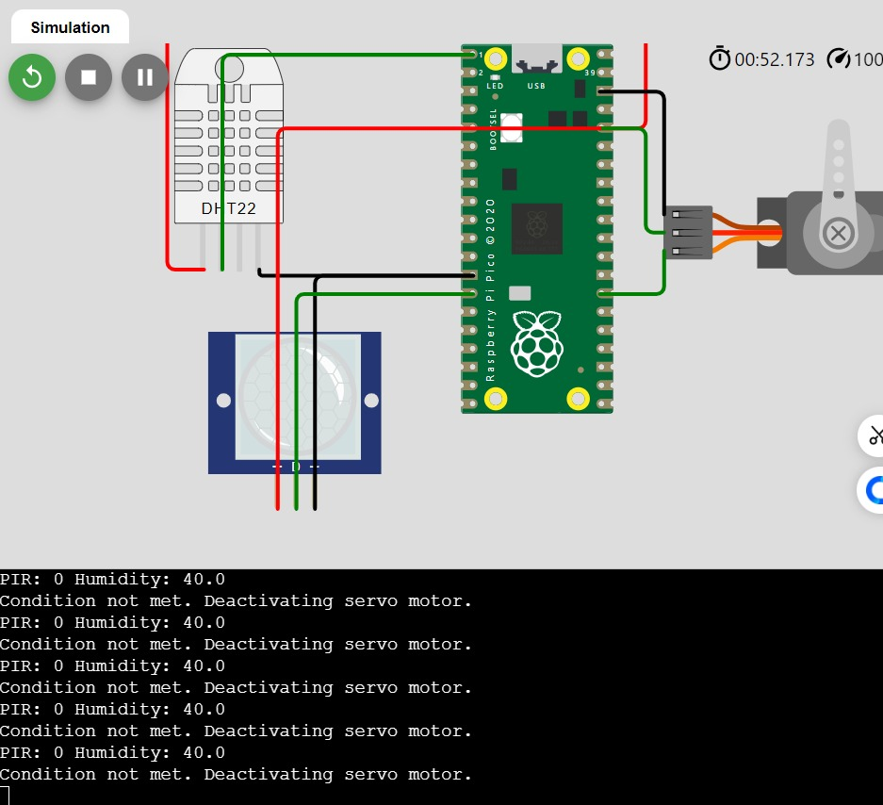ram stopped")